*□ *

Developer: Team Princess

Publisher: Chapman University

Engine: GameMaker

Development Start: November 29, 2016

Release: May 10, 2017

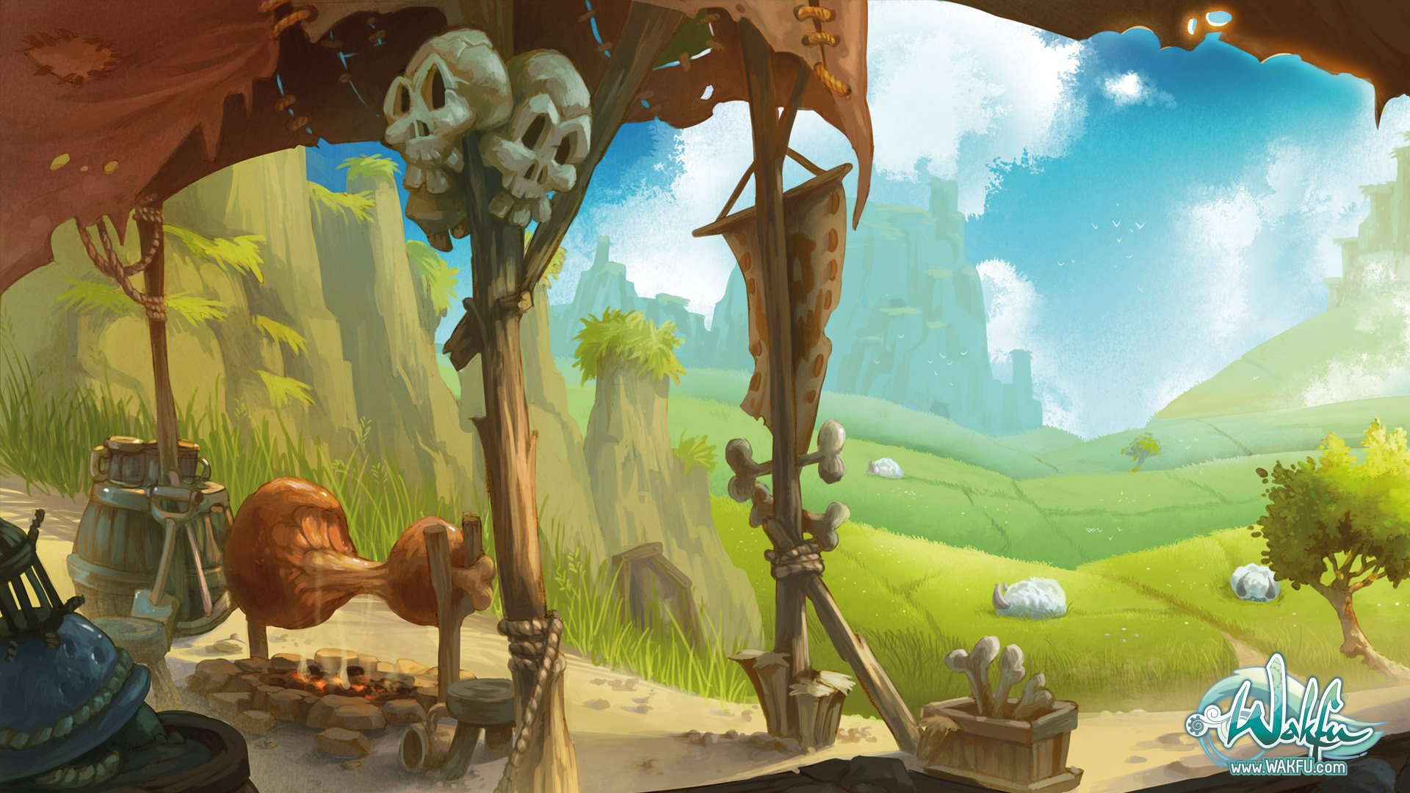

(art to be updated with relevant in-game art)

**Table of Contents**

Team

Programming

Design

Art

Sound

Writing

Management

Target Platforms

Platform

Version Control

Dynamics

Aesthetics

Mechanics

Game Style

Level Layouts

Combat

Characters

Items

Narrative

Story

Levels

Main Missions

Side Missions

Milestones

# Team

**Programming**

Kevin Hewitt

Logan Jensen  
Mike Stimpson

**Design**

Lee Feldman

**Art**

Logan Jensen

Mike Stimpson

**Sound**

Logan Jensen

**Writing**

Lee Feldman

**Management**

Lee Feldman

# Target Platforms

PC

Implementation: C#

Software: GameMaker v1.4

Deliverable: .exe file

# Version Control

<https://github.com/LAFworks/PrincessGame>

# Dynamics

At the start, players will pick from the available Hero Classes and select three Heroes. Players can then immediately embark on their adventure or spend time in the starting city, Lionwell, to purchase gear or boost their levels. Upon leaving the city, players will begin experiencing randomly-generated encounters during their journey toward the end-game battle with Malethrax. Random encounters will include combat (which will take place in a *Final Fantasy*-esque turn-based battle system), textual story interactions, shop opportunities, and other beneficial or detrimental effects. The game’s ending and rewards for the player will be determined by how quickly they beat the game and if certain optional objectives were completed.

# Aesthetic

2D Pixelized

Similar Titles

*Rogue Legacy*

*Knights of Pen and Paper*

*FTL: Faster than Light*

*Oregon Trail*

*Final Fantasy*

# Mechanics

Game Style

Roguelike role-playing game. Players create a party of three Heroes and determine which path they will take to reach the final boss, Malethrax. Players will navigate a large world map, populated with random events and unique nodes, akin to *Final Fantasy*. At the start of a new game, players are given a set amount of time to accomplish their goal, although failing at the main task is still an option. The game’s endings are determined by whether the player defeated Malethrax and how much Time is remaining. Each action players take, whether shopping, resting, combat, or traveling, takes a portion of Time. If all Heroes are killed, the game is over. If the player defeats Malethrax but not within the allotted Time, they receive the Bad Ending and keep only a small portion of loot for New Game +, but if Malethrax is beaten with Time to spare, the player earns the Good Ending and keeps a much larger portion of loot.

Level Layouts

Every playthrough uses the same world map, the primary difference stemming from the random events players will encounter. Certain zones will have unique events and others have the chance to appear anywhere, but remember: there’s a possibility that every step could be your last! Players can land on combat spaces, event spaces, loot spaces, merchant spaces, or trap spaces. These events can immediately affect the player or set up a consequence for later on in the game.

Combat

Upon landing on a combat space, players are taken to a turn-based battle system, akin to *Final Fantasy*. Each character, friendly and hostile, has a speed statistic which determines turn order in a fight. Speed can be affected by class, equipment, status effects, etc. The player must use their Heroes to defeat whatever enemies they encounter. They could be a band of orcs, a die-hard thief looking to strike it rich, or even other adventurers looking to claim your glory. Combat ends upon defeat of either all enemies or death of all the player’s Heroes.

Characters

There are nine total Hero classes that can be unlocked (for now; more to potentially be added!). The three available from the beginning are the Paladin, the Ranger, and the Wizard. Unlockable classes include the Barbarian, the Necromancer, the Druid, the Monk, the Thief, and the Bard. Each class has different active and passive abilities, which affect how the game can be played. The abilities are as follows:

|  |  |  |
| --- | --- | --- |
| **Class** | **Active Abilities** | **Passive Abilities** |
| Barbarian | Berserker Rage: For *x* number of turns, the Barbarian deals increased damage and has increased luck, but takes more damage. | Intimidate: Unlocks the ‘Intimidate’ conversation option; because of his burly stature and generally unfriendly face, the Barbarian can scare some people into doing what he wants. |
| Bard |  | Charm: Unlocks the ‘Charm’ conversation option; occasionally, the Bard can use his silver tongue to diffuse a situation and still earn a reward. |
| Druid |  |  |
| Monk |  |  |
| Necromancer |  |  |
| Paladin |  |  |
| Ranger |  |  |
| Thief |  | Treasure Map: Nearby loot spaces will glow; The Thief’s cunning knack for finding treasure allows him to quickly and easily spot an overlooked gem. |
| Wizard |  |  |

Items

Players can earn loot by defeating enemies, purchasing them through merchants, or landing on a loot space. Each hero can equip a weapon, a piece of armor, and an accessory. Other items include consumable potions, additional inventory slots, side-quest items, and sellable junk.

# Narrative

Story

The dreaded Demilich Malethrax has kidnapped Princess Carina, the beautiful and sole daughter of King Calvin, Sovereign Ruler of Lionwell. He has demanded that the king pay a large ransom within a week’s time, or else the princess will be executed. Unluckily for the King, the royal coffers have recently been drained to build a new bridge, ironically dedicated to Princess Carina. Calvin has met with a small group of traveling heroes and implored them to rescue his daughter from the clutches of Malethrax, promising a great reward. This band of adventurers set out from Lionwell proper, before they realize a critical detail: they’re not the only ones the king has made this offer to.

# Levels

Main Missions

The main purpose of the game is to rescue Princess Carina from Malethrax. Players will have a week allotted in the game; if the player does not reach Malethrax’s fortress before this time, the princess will be killed and the player will earn the bad ending (if they manage to survive).

Side Missions

Throughout the game, the player can encounter side quests which have no bearing on the main story. Completing these additional missions will reward the player with loot (or maybe a new Hero), but doing these tasks can eat up precious Time. An example of one-such side-mission is to deliver food stores from one town to another and defeat any enemies along the way who may want to take the food for themselves.

# Milestones

November 29, 2016 – Primary Pitch

December 13, 2016 – Prototype Presentation

January 21, 2017 – First Meeting of Collaborative Game Development

March 1, 2017 – Alpha Version complete (five template events, combat system implemented, map designed, random event generator, character/environment art)

April 1, 2017 – Beta Version complete (50 events implemented, combat system finished, enemy art, complete movement on world map, loot system, equipment system)

May 10 – Release (Three playable classes, complete story, 100 random encounters, all art complete)